**CHAPTER 1**

**OBJECTIVE**

**Spreading Public Awareness for Positive Change**

* **Raising awareness is essential** for addressing significant issues and driving meaningful change.
* **Open conversations, accurate information, and social media** help reach a larger audience.
* **Educating others** empowers individuals to make informed choices and take collective action.

**Effective Awareness Activities**

* **Hosting educational workshops, seminars, and webinars** to provide insights on key issues.
* **Distributing brochures, flyers, and posters** to spread messages to a wider audience.
* **Organizing community gatherings, rallies, and campaigns** to foster public participation.
* **Leading by example through direct action**, such as cleanup efforts, instead of just advising.

**Importance of a Clean Society**

* **Enhances public health** by reducing disease spread and improving overall well-being.
* **Creates a visually appealing environment**, making public spaces enjoyable for all.
* **Fosters responsibility and pride**, encouraging active participation in cleanliness efforts.

**Ways to Promote Cleanliness and Awareness**

* **Leading by action** to inspire responsible waste management.
* **Encouraging discussions on environmental conservation** and pollution impacts.
* **Sustained community involvement** ensures a cleaner and healthier environment for future generations.

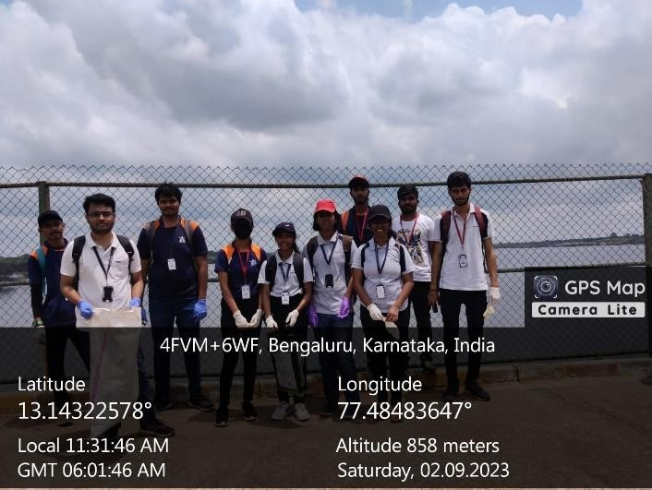

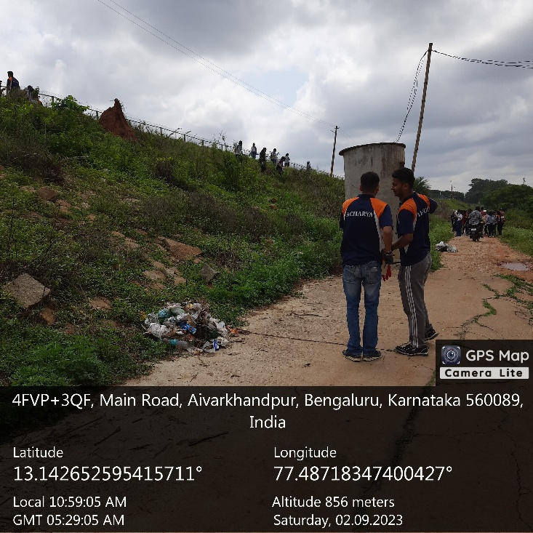

**CHAPTER 2**

**ABOUT THE PLACE**

**1. General Overview**

* **Man-made reservoir** located in **Karnataka, India**, on the **northwestern outskirts of Bangalore**.
* Situated **approximately 20 km from Bangalore city center**.
* Originally served as a **primary drinking water source** and an **irrigation facility** for nearby agricultural areas.
* Over time, transformed into an **ecological and recreational hub** attracting nature lovers and conservationists.

**2. Historical Significance**

* **Constructed in 1894** as part of the **Chamarajendra Water Works project** under British rule.
* Designed to **supply drinking water to Bangalore**, which faced shortages due to its elevated plateau location.
* **Fed by the Arkavathi River**, ensuring a steady water supply for both **drinking and agriculture**.
* Played a **vital role in Bangalore’s early water management** before the modern **Cauvery water supply system** was introduced.
* Though no longer a primary **drinking water source**, it remains an **important historical and cultural landmark**.

**3. Ecological Importance**

* Functions as a **thriving ecosystem** supporting diverse **flora and fauna**.
* Serves as a **wetland habitat** essential for **migratory birds, aquatic species, and local wildlife**.

**Key Ecological Features**

* **Birdwatching Haven** – Home to **over 200 bird species**, including:
  + Herons, egrets, pelicans, kingfishers, and cormorants.
  + Rare migratory species arrive during certain seasons, making it a **hotspot for ornithologists and photographers**.
* **Wetland Ecosystem** –
  + Marshy and grassy areas serve as **breeding grounds for birds, small mammals, and aquatic species**.
  + Wetlands help **filter pollutants and maintain ecological balance**.
* **Flora and Fauna** –
  + The surrounding region includes **grasslands, shrubs, and aquatic vegetation**.
  + Supports a variety of **frogs, butterflies, and reptiles**.
* **Groundwater Recharge** –
  + Plays a **crucial role in replenishing groundwater levels** in the surrounding areas.
  + Contributes to **sustainable water management**.

**4. Environmental Threats and Conservation Efforts**

* Faces threats such as **water pollution, encroachment, and declining water levels** due to urbanization.
* Conservation efforts focus on **restoring ecological balance and preserving biodiversity**.
* The lake remains a **valuable ecological zone** that requires **careful preservation and sustainable management**.

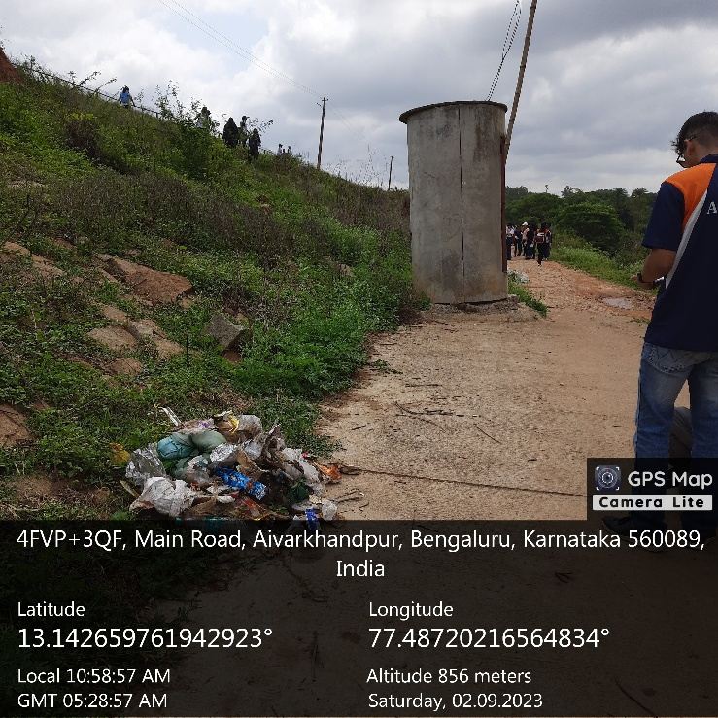

**CHAPTER 3**

**ACTION PLAN**

|  |  |  |  |  |
| --- | --- | --- | --- | --- |
| **SLNO** | **DATE** | **ACTIVITY** | **DURATION** | **REMARKS** |
| 01 | 02-09-2023 | Visiting places and Enquiring | 3 | Visited Places And Enquired about places |
| 02 | 03-09-2023 | Cleaning Roads | 7 | Cleaned Roads |
| 03 | 03-09-2023 | Cleaning Roads | 7 | Cleaned Roads |
| 04 | 03-09-2023 | Promote Cleanliness | 7 | Promoted Cleanliness |
| 05 | 03-09-2023 | Promote Cleanliness | 7 | Promoted Cleanliness |
| 06 | 05-09-2023 | Collecting wastes | 7 | Collected Wastes |
| 07 | 05-09-2023 | Collecting wastes | 7 | Collected Wastes |
| 08 | 05-09-2023 | Collecting wastes | 7 | Collected Wastes |
| 09 | 08-09-2023 | Cleaning Public Places | 7 | Cleaned Bus stops |
| 10 | 08-09-2023 | Cleaning Public Places | 7 | Cleaned Bus stops |
| 11 | 08-09-2023 | Cleaning Public Places | 7 | Cleaned Public places |
| 12 | 10-09-2023 | Gathering geo tag photos and making detailed report | 3 | Made a detailed Report |

**CHAPTER 4**

**CONDUCTION OF THE ACTIVITY**

**1. Purpose and Background**

* **Hesaraghatta Lake** is a **historically and ecologically significant** water body in Bangalore.
* Faces increasing **pollution and waste accumulation** due to frequent human activities.
* Major environmental issues include:
  + **Littering and improper waste disposal**.
  + **Accumulation of plastic, food waste, and non-biodegradable materials**.
  + **Threats to local wildlife and biodiversity**.
* Recognizing the urgency, the team undertook a **clean-up drive** to restore and safeguard the lake’s surroundings.

**2. Organizing the Clean-Up Drive**

* **Systematic planning and execution** ensured effective waste collection.
* Participants were divided into teams, each covering specific zones:
  + **Waste Collection Team** – Picked up plastic, paper, and other non-biodegradable waste.
  + **Water Cleanup Team** – Removed floating waste and pollutants near the lake’s shore.
  + **Sorting & Disposal Team** – Separated waste into **recyclable and non-recyclable** categories for proper disposal.
  + **Supervision & Safety Team** – Ensured **safety measures and waste disposal guidelines** were followed.
* **Precautionary Measures:**
  + Faculty and organizers **oversaw the event** to ensure safe and proper waste disposal.
  + Participants were provided with **gloves, garbage bags, and cleaning tools**.
* **Key Clean-Up Actions:**
  + Removed **plastic bottles, wrappers, food containers, and pollutants** from:
    - **Walking trails**.
    - **Picnic areas**.
    - **Lake edges**.
  + Observed alarming pollution levels, reinforcing the need for **ongoing environmental efforts**.

**3. Impact & Key Learnings**

**Positive Outcomes:**

* **Immediate Improvement in Cleanliness** – Waste removal enhanced the area’s **hygiene and visual appeal**.
* **Increased Awareness Among Visitors** – Passersby **recognized the importance of responsible waste disposal**.
* **Reinforcement of Environmental Values** – Demonstrated that **small efforts collectively create a big impact**.
* **Encouraging Sustainable Habits** – Participants learned about:
  + **Reducing plastic usage**.
  + **Recycling waste properly**.
  + **Promoting eco-friendly lifestyle choices**.

**Key Takeaways:**

* Keeping public places clean is **not just the responsibility of authorities but of every individual**.
* **Cleaning is only part of the solution** – the real challenge is **preventing pollution in the first place**.
* Regular initiatives like this can **help maintain natural spaces and encourage sustainable behavior** in communities.

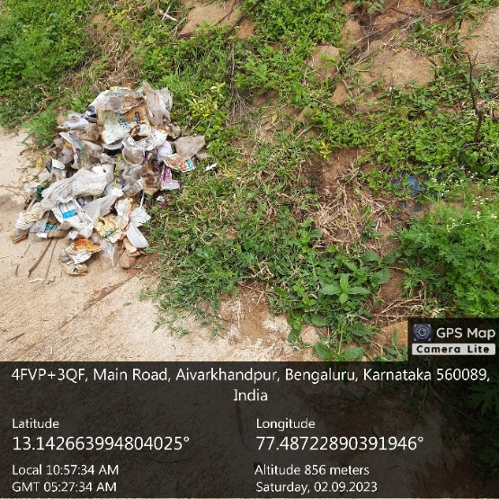

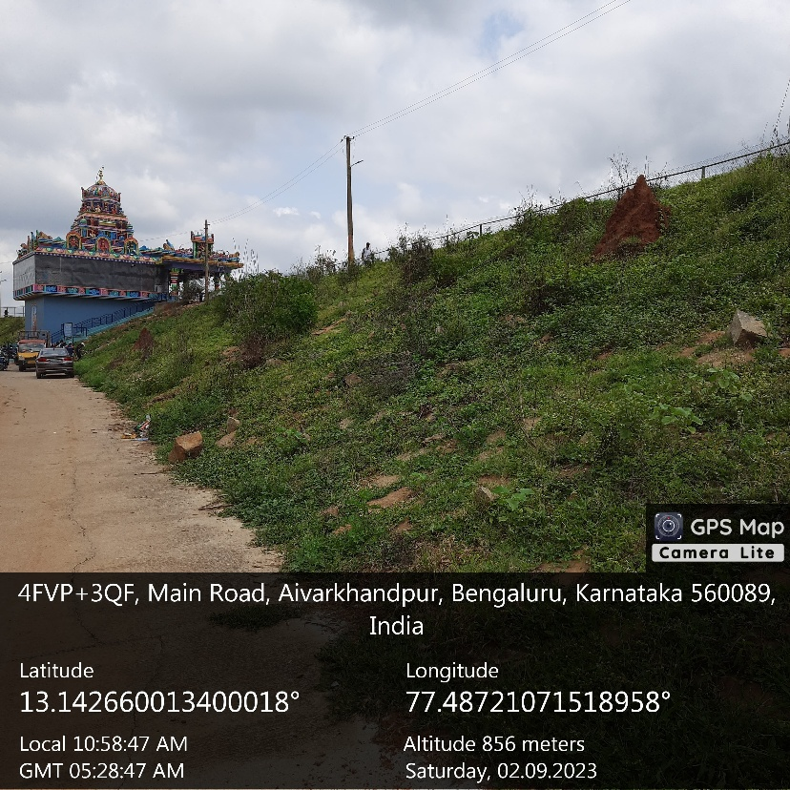

**OUTCOMES**

**1. Importance of Waste Management**

* **Natural resources are finite**, making their **effective management crucial** for future generations.
* Ensuring resource availability requires **efficient waste management strategies** for:
  + **Medical waste**
  + **Household waste**
  + **Industrial waste**
* The study assesses **public awareness, attitudes, and behaviors** toward waste disposal and its environmental impact.

**2. Research Approach**

* Utilized **survey-based research** to evaluate public knowledge and awareness.
* Survey focused on **waste disposal practices, environmental awareness, and public behavior**.
* **Participants:** Pharmacy students receiving **laboratory training in the healthcare field**.
* **Objective:** Understand how individuals in **scientific and medical disciplines** perceive waste management.

**3. Data Analysis Methods**

* **Internal consistency reliability tests** ensured the questionnaire's reliability.
* **Statistical analysis techniques applied:**
  + **Pearson correlation** – Measured relationships between variables.
  + **t-tests and ANOVA (Analysis of Variance)** – Analyzed differences in awareness based on:
    - **Demographics**
    - **Educational background**
    - **Environmental organization membership**

**4. Key Findings**

* **Educational background, gender, and environmental engagement** significantly influence:
  + **Waste management awareness**
  + **Disposal behavior**
* Highlights the need for:
  + **Public education programs**
  + **Waste management policies**
  + **Awareness campaigns** to improve waste disposal practices.

**5. Recommendations for Improvement**

* **Encourage participation in environmental organizations** to foster responsible waste practices.
* **Incorporate waste management training** into educational curricula.
* **Promote public awareness campaigns** to instill sustainable behaviors.

**6. Conclusion**

* Raising **public awareness and responsible waste management** is key to:
  + **Environmental protection**
  + **Sustainable resource use for future generations**.